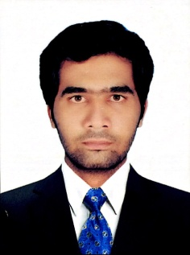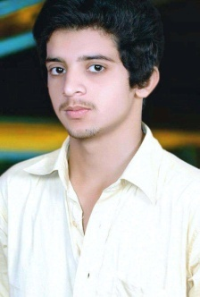

About

To work in an organization where I can fully utilize my knowledge to achieve the highest efficient and also achieve the target and developing the best performance in the organization. I would like to implement my innovative idea, skills and creativity for my accomplishing the goal.

Education

Bs (Software Engineering)

Continue

University of Sindh, Jamshoro.

Higher Secondary Certificate

Passed “B” Grade

B. I. S. E Larkana

Secondary School Certificate

Passed “B” Grade

B. I. S. E Larkana

Experience

I have been working on my skills for 1.5 years.

Skills

* Adobe Photoshop, Adobe illustrator.
* Frontend (HTML, CSS, JS, BOOSTRAP).
* Backend (Laravel).

REFERNCES

Will be furnished on demand.

**ZUHAIB ALI**

**Father Name: AIJAZ ALI**

**CNIC No: 43202-6968240-3**

**Domicile: Qambar Shahdadkot**

**CONTACT**

**House No.69 Harka Muhallah, Ali Khan, Kamber**

**0305-2489390**

**zuhaibsoomro25@gmail.com**

**LANGUAGE**

**English**

**Sindhi**

**Urdu**

**SKILLS**

**Critical Thinking**

**Problem Solving**

**Flexible/Dependable**

**Interpersonal Skills**

**Motivated**